**Benjamin Netanyahu**

**Prime Minister of Israel, Defense Minister**

**Assassinated**

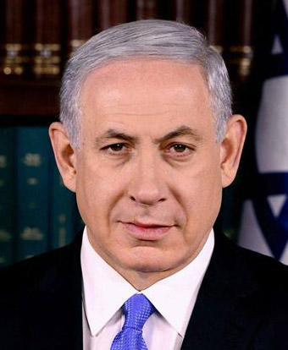

**In Berlin Germany**

**On September 16, 2021**

**This told by Archangel Michael**